***Lyddie***

***Chapter 1-  The Bear***

***Summary:***

Chapter 1 of [*Lyddie*](https://www.enotes.com/topics/lyddie?en_action=hh_answer_body_click&en_label=%2Fhomework-help%2Fwhat-summary-chapter-1-lyddie-by-katherine-22735%23answer-734718&en_category=internal_campaign) starts off very quickly and with a lot of intensity. Normally, I don't like chapter 1 of most books because you don't get a good feel for the characters until later. Additionally, there isn't generally too much action in chapter 1. This is not the case with chapter 1 of Lyddie. The reader is first introduced to Lyddie and her family on their farm in Vermont. Very shortly after that, a bear enters their cabin and starts wreaking havoc. Everybody runs for cover except Lyddie, who bravely stares down the bear.

Lyddie's mother takes the entire situation as a bad sign. She takes herself and the two youngest children to live at her sister's place. Lyddie and Charles refuse to go. They take care of the farm for the entire winter, and actually manage quite well. They even oversee the successful birth of a calf.

Unfortunately, when spring comes, so does a letter from their mother. Charles and Lyddie are being sold into indentured servitude in order to help pay off family debts. Lyddie is supposed to go to Cutler's Tavern.

We are introduced to Lyddie deep in the rural areas of Vermont because a bear enters her family's little cabin and wreaks havoc.  This bear is Lyddie's first obstacle in life and begins to symbolize the other, bigger obstacles she will tackle as she moves toward becoming a "Lowell Factory Girl."  It is Lyddie, always showing her spunk, who protects her family by "staring the bear down."  Unfortunately, the bear frightens Lyddie's mentally unstable mother enough to make her leave with the babies, leaving Lyddie--and eventually Lyddie's younger brother, Charlie--alone to tend their Vermont farm.

Just as things begin looking up for Lyddie and Charlie, in that they make it through the cold winter months and observe the birth of a calf from their one and only cow, they get a note from their mother saying that she has rented them as workers to other farms in order to pay her debts.  Even though their mother also writes, "We can still hope," all hope seems to have vanished by the end of this chapter.  Now Lyddie must go out in search of hope for herself.

Chapter 1 opens with an incident that changes the life of Lyddie and her family.  A bear invades their house and, as Lyddie, Mama, and the younger children clamber to safety in the loft, it is clear that Mama is not completely lucid and that thirteen-year-old Lyddie is the one who takes care of everyone.  Believing that the bear is a sign that the world will soon be destroyed, Mama decides that they must go to stay at her sister's place so as "to be with the faithful when the end comes."  Lyddie and ten-year-old Charlie refuse to go because they still have hope that Papa, who went away when he couldn't make a living for the family on the farm, will return as he promised; so they stay behind and manage quite efficiently to make it through the winter.  In the spring, Lyddie and Charlie receive a letter from Mama telling them that she has hired both of them out to pay the family's debts.  Lyddie is to go to work at Cutler's Tavern and Charlie at Baker's Mill.

***Summary in Detail:***

The bear had ruined the family. It had been 1843 when the bear came.  Rachel was six and Agnes was four.  It was Charles' fault that the bear got into the house.  He had gone outside to get firewood and had left the door open.  Lyddie had looked up from the pot of oatmeal she was stirring to see the big black bear standing in the doorway.

Lyddie said "don't nobody yell just back up slow and quiet to the ladder and climb up to the loft.  Charlie, you get Agnes, and Mama, you take Rachel." Lyddie heard Mama make a soft crying noise.  Lyddie said, "It's all right long as nobody gets upset.  Just take it nice and gentle ey?"

Even though everyone was afraid they listened to Lyddie.

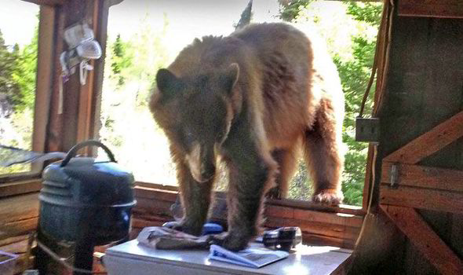

Lyddie told everyone to walk quietly up the ladder to the [loft](http://bookbuilder.cast.org/view_glossary.php?book=109927&word=85058#curr)  so that the bear couldn't reach them.  Agnes, Charles, Rachel, and Mama made it up the ladder safely so Lyddie started inching her way slowly up the ladder.  Finally, Lyddie made it to the top and Charles pulled her up.

Then, the bear ran for the ladder, but Charles was able to pull it away from the bear's reach.  Mama was scared and yelled "Oh  Lord, deliver us!".

Lyddie said to Mama "hush, you'll just make him madder".  Mama stopped yelling and gasped for breath quietly to stop herself from screaming.

Lyddie and her family watched the bear from the loft as he started to explore the [cabin](http://bookbuilder.cast.org/view_glossary.php?book=109927&word=85059#curr) .  The bear was hungry and looking for food.

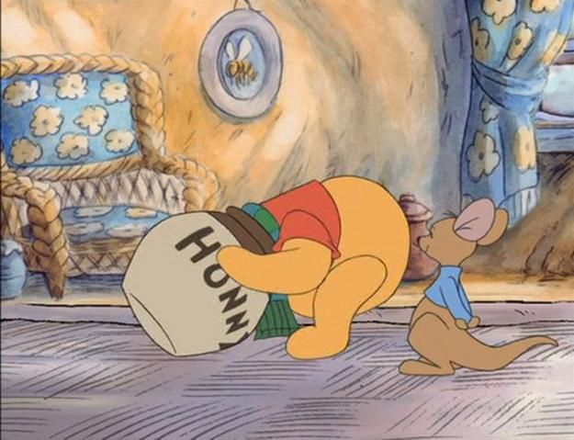

Lyddie held her breath as she watched the bear walk around the cabin.  The bear had already flipped over the benches and the spinnnig wheel.  Lyddie held her breath, praying that he wouldn't break anything.  They couldn't [afford](http://bookbuilder.cast.org/view_glossary.php?book=109927&word=85060#curr)  to [replace](http://bookbuilder.cast.org/view_glossary.php?book=109927&word=85061#curr) anything if the bear broke it.

Then the bear found the pot of hot oatmeal cooking on the fire.  He put his head in and the pot got stuck on his head! The boiling hot oatmeal was pouring down the bears' head and neck.  The bear was too stunned, it seemed, to simply lower his neck and let the kettle fall off.  He danced about the room in pain on four, then two legs, the kettle covering his head, the boiling oatmeal raining down his thick neck and [coat.](http://bookbuilder.cast.org/view_glossary.php?book=109927&word=85062#curr)

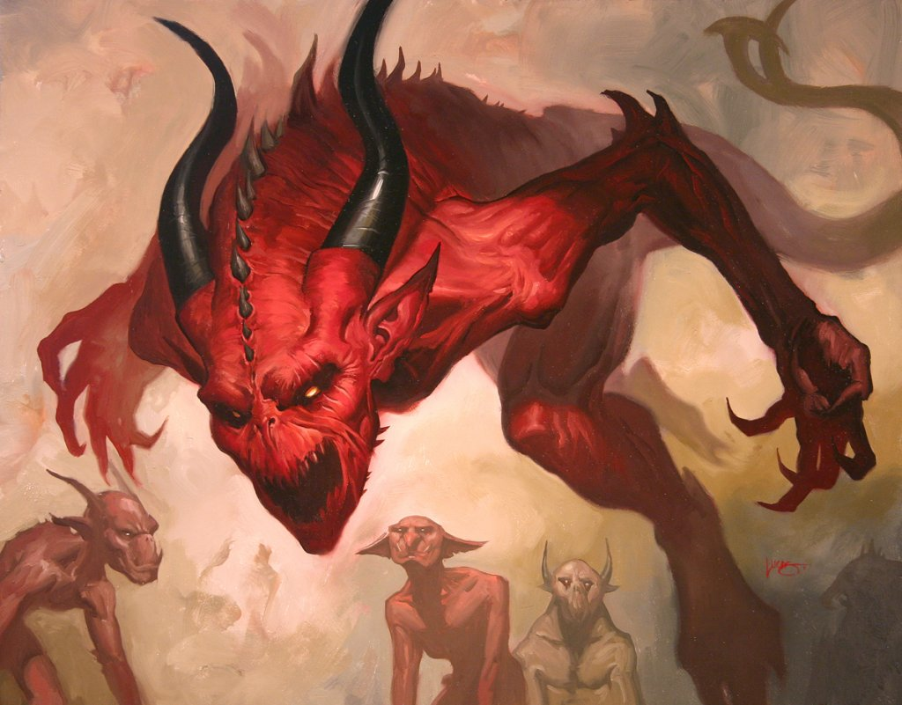

As soon as the bear stumbled out of the cabin in pain Lyddie and her family couldn't help but burst out laughing.  The only person not laughing was Mama.  Mama said she thought the bear was really the devil who had come to find them.  Mama's sister, Aunt Clarissa, had told her the devil was coming and Mama was sure this was it.

Lyddie tried to calm down Rachel who was nervous about what her mother had said.

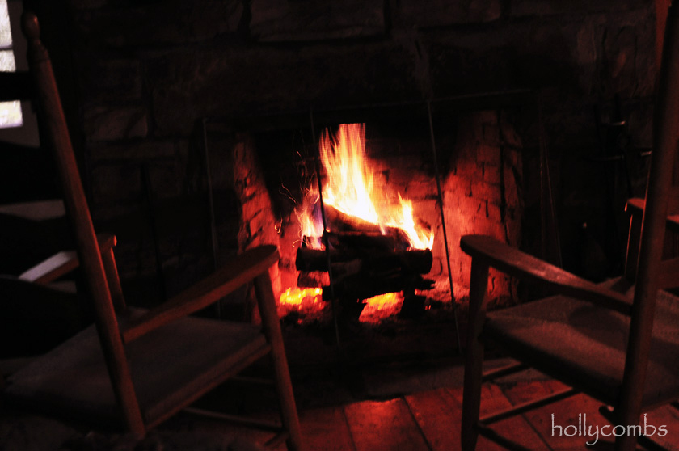

Mama tells Lyddie and her siblings that "Tomorrow we are going to Poultney" because she wants to be near her sister when the end of the world comes.  Mama believes the end of the world is coming because of the bear and wants to be near her sister who is very religious in hopes of being saved.

Charles gets upset that they might have to leave their family farm and says, "But how will Papa find us if we've left home?"

Mama replied, "Your father went out searching for vain riches and he ain't never coming back".

Racheled cries "He will come back! He promised!"

Their father had left when they were little to search for a way to make more money for the family but had never come back.  Ever since father left, Lyddie knew Mama had not been herself.  When everyone went to bed, Lyddie saw Mama sitting by the fire staring into the fireplace and rocking back and forth with an empty look in her eyes.

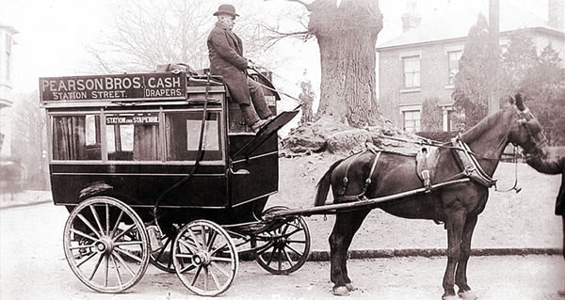

Lyddie tells Mama that even if they all leave she can't leave the farm.  She tells her that even if she wanted to come they won't be able to afford [coach fare](http://bookbuilder.cast.org/view_glossary.php?book=109927&word=85063#curr)  for the whole family so she will stay behind.

Charles takes their pig to sell in order to get enough money for the family to go to Aunt Clarissa's in Poultney.

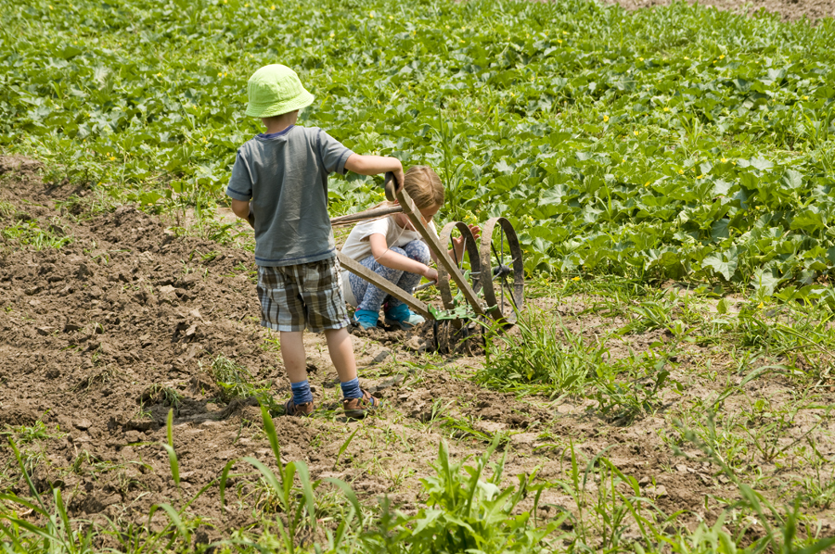

Two weeks later...

Charlie returned from helping his mother and Agnes and Rachel get to Poultney safely and him and Lyddie were able to survive the harsh winter in their cabin.  The two of them shot rabbits and peeled bark to use to make soup to help themselves survive.  They had almost no supplies and no money, but they survived.

Lyddie and Charlie were waiting for a new baby cow to be born so they could have milk and butter again.  When the calf, or baby cow, was born they were so excited they [rejoiced.](http://bookbuilder.cast.org/view_glossary.php?book=109927&word=85064#curr)

Even though it was hard and Lyddie and Charlie were so young, they were able to start [tapping the trees for maple sugar](http://bookbuilder.cast.org/view_glossary.php?book=109927&word=85065#curr)  and soon were able to start [plowing](http://bookbuilder.cast.org/view_glossary.php?book=109927&word=85066#curr)  the land to plant [crops.](http://bookbuilder.cast.org/view_glossary.php?book=109927&word=85067#curr)

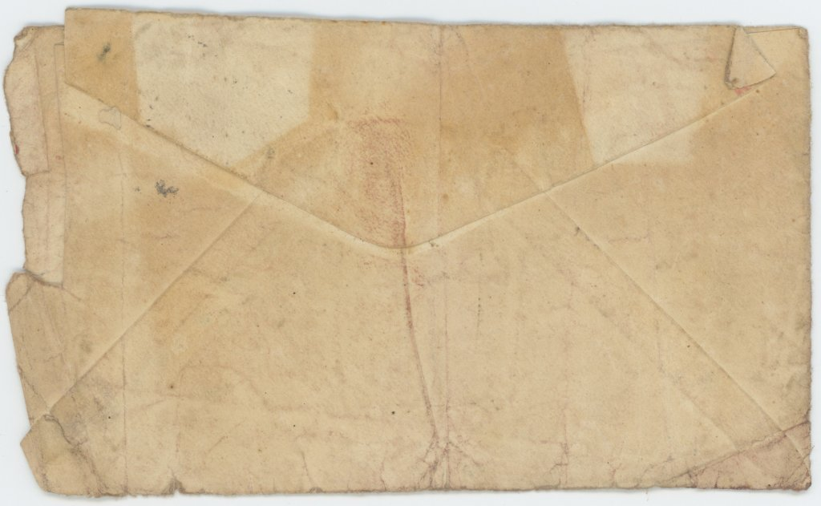

One spring morning, Lyddie and Charlie saw someone riding a horse coming towards their cabin. The rider turned out to be Mrs. Peck who had brought a letter for Lyddie and Charlie.

Lyddie paid Mrs. Peck for dropping off the letter and then read the letter with Charlie.  It said:

Dear Lyddie,

The world hav not come to the end yit .  But we can stil hop. Meentime I hav hire you out to M. Cutler at the tavern and fer yr. brother to Baker's mill.  The paschur feelds and sugar bush is lent to M. Wescott to repay dets.  Also cow and horse.  Lv. at once when you git this.

                           Yr. loving mother,

                            Mattie M. Worthern

Lyddie burst into tears after she read the letter.  She couldn't believe Mama was lending out the farm and the animals to pay back money to people and that she and Charlie were being sold off to different places to work.

Charlie tried to make Lyddie feel better, but there was not much either of them could do to make the situation any better.